[Video description:
A black screen with white text for title: “History - MD Interpreter Licensure Work Group. Feb. 2019” . Fading into a video of a white Deaf woman sitting and wearing a maroon sweater with both sleeves pulled up, with a beige background, A subtitle at bottom left corner shows: “Kirsi Grigg-Langdon, interim chair for WG”.
She began to sign:
Hello, my name is Kirsi Grigg-Langdon and I am a chair for the workgroup behind Maryland Sign Language Interpreter Licensure bill.
I have not been the chair for years, but relatively recent for an year or two. However the efforts of this workgroup has predated me and represents an accumulation of many years-- and I want to share that history with you all to get us on the same page of where this bill came from.
Licensing began as a conversation in Maryland back in 2009.
At the time, the DC Council was considering a change in legislation concerning the needs of Deaf citizens and the licensing of interpreters became a part of that. Ultimately, that effort did not move forward.
PCRID decided to establish a Legislative Affairs Committee to address future legislation regarding interpreting services in both Maryland and DC.
In 2013, licensing of interpreters in Maryland received new attention as MDAD was given a membership mandate to pursue licensing in the state of Maryland.
PCRID requested to be a part of this process and a workgroup was formed.
The bill was shelved in 2015 as a result of RID (Registry of Interpreters for the Deaf)'s moratorium on testing.
When RID established the Center for the Assessment of Sign Language Interpretation (CASLI), the workgroup was renewed.
At the end of 2017, a draft bill was sent to the Maryland Legislature, and the bill was not taken up.
The Legislative Affairs Committee and the workgroup continued to revise the legislation and work to include stakeholder feedback while waiting for the results of the 2018 elections to settle the political landscape.

In February of 2019, the draft bill was sent to the Maryland Legislature and it was accepted; HB1064 has been placed on the docket.
The draft bill writing working group was comprised of the last ten years and over 20 people represented organizations and stakeholder groups in Maryland.
That is how we arrived to where we are today. “

Faded into black.
End of video description.]

You may read a copy of the draft bill here. Testimony for HB1064 will be heard on March 12, 2019, at 1:00 PM. Interpreters will be provided.

The Workgroup is working to collect the supporting testimony required for the bill. If you are in support of this bill, please submit your written testimony by March 10, 2019 by filling out this google form: #YEStoHB1064

You may also visit the MD Interpreter Licensure website, which was established by the workgroup to document history and updates on the bill.
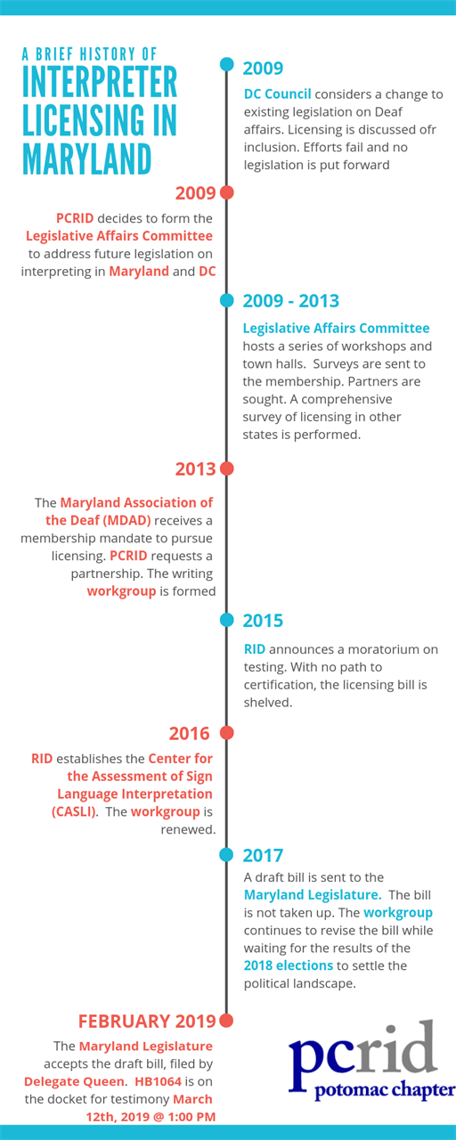
(image source; http://pcrid.org/resources/Timeline%20of%20Interpreter%20Licensing.png)

